Introduction to CSS

What is CSS ?
CSS (Cascading Style Sheets) is a Stylesheet language used to style and design web pages.

It controls how HTML elements look on the Screen , paper or other media.

HTML = Structure
CSS = Design (colors , layout , fonts, spacing)

Why CSS is Used
Css is used to :

- Make website attractive
- Control layout and positionning
- Apply colors , fonts , and spacing
- Create responsive design for mobile & desktop
- Separate content (HTML) from design (CSS)

How CSS works

Css works by selecting HTML elements and applying styles to them

Example:

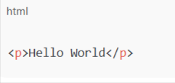

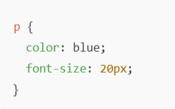

What Does “Cascading” Mean?
“Cascading” means priority order when multiple styles apply.

Priority

- Inline CSS (highest)
- Internal CSS
- External CSS (lowest)
- Browser default (last)

CSS Versions

- CSS1 - Basic styling
- CSS2 - Positioning , media types
- CSS3 - Mordern features (Flexbox , Grid , Animations)

✔ CSS3 is not one file , it’s a collection of modules.

Advantages of CSS

- Reduces code repetition
- Faster page loading
- Easy maintence
- Better user experience
- Responsive design support

